

Computer Networking (CSE 311)
Topic: Wireshark lab on TCP

Submitted To:
Dr.MD. Shariful Islam
Professor
IIT, University of Dhaka

Submitted By:
Name: Mst. Fareya Azam
Roll: 1331
Submission date: 19th March,2023
Answer to the question no:1
The IP address used by the client computer (source) that is transferring the file to gaia.cs.umass.edu is 10.100.103.204 and the port number is 65293.
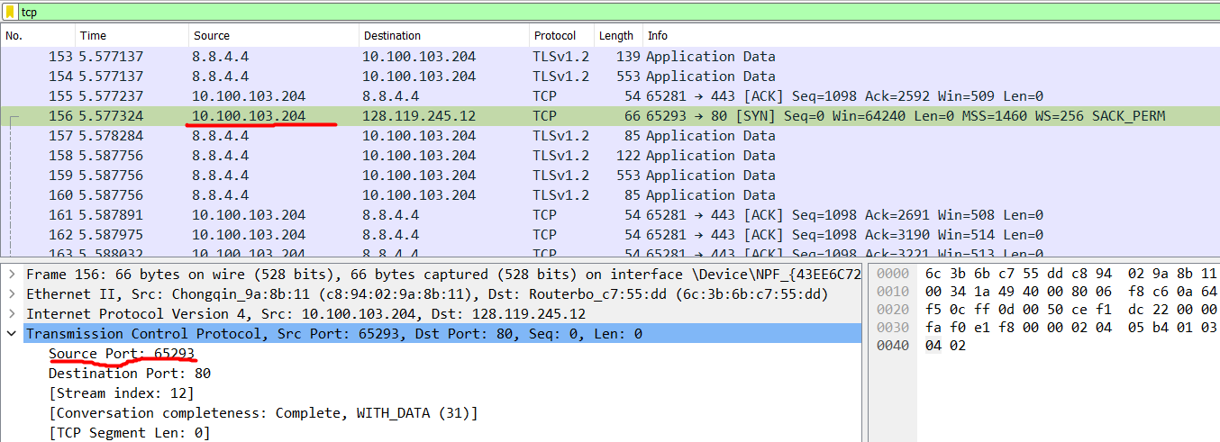

Answer to the question no:2
The IP address of gaia.cs.umass.edu is 128.119.245.12 and port number is 80 which is used in sending and receiving TCP segments for this connection.
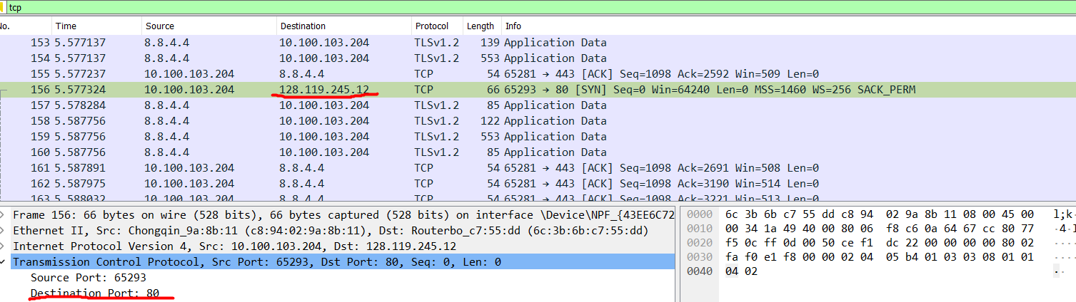
Answer to the question no:3
Yes, I have been able to create my own trace. The IP address used by the client computer (source) that is transferring the file to gaia.cs.umass.edu is 10.100.103.204 and the port number is 65293.

Answer to the question no:4
The sequence number of the TCP SYN segment that is used to initiate the TCP connection between the client computer and gaia.cs.umass.edu is 0. The segment that identifies the segment as a SYN segment is Flag : SYN set =1.
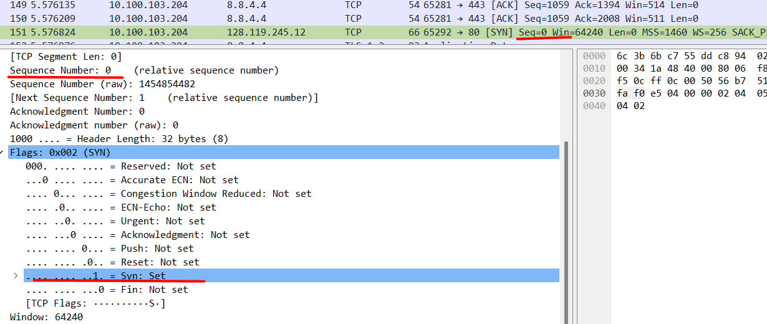

Answer to the question no:5
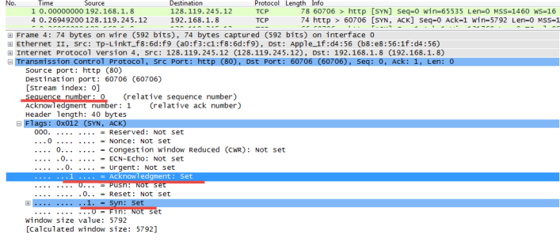
According to the above figure, the sequence number of the SYNACK segment sent by gaia.cs.umass.edu to the client computer in reply to the SYN is 0. The value of the acknowledgement field in the SYNACK segment is 1. The value of the acknowledgement field in the SYNACK segment is determined by the server gaia.cs.umass.edu. The server adds 1 to the initial sequence number of SYN segment form the client computer. For this case, the initial sequence number of SYN segment from the client computer is 0, thus the value of the acknowledgement field in the SYNACK segment is 1. A segment will be identified as a SYNACK segment if both SYN flag and Acknowledgement in the segment are set to 1.

Answer to the question no:6
According to the figure, the segment No.6 contains the HTTP POST command, the sequence number of this segment is 1.
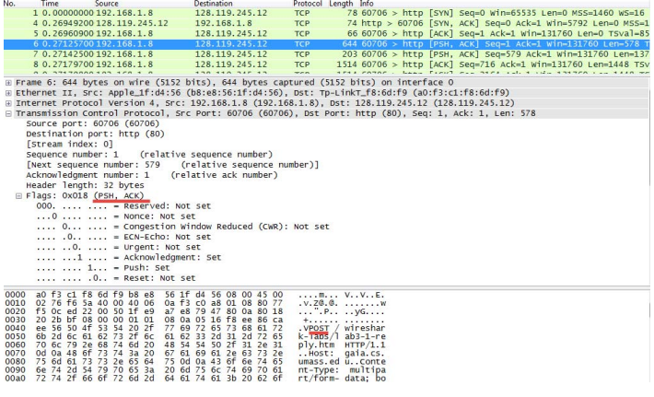

Answer to the question no:7
